Capstone Proposal

Do Together (DoTo): A Social Android App to plan your social to-do list

Cordin Hull – April 12, 2021

**Paragraph Description**

My android application will be designed for person-to-person social scheduling. The target audience for the application would be those needing help connecting with those around them, either by lack of social connections in life, recently moved to a new location where they don’t know anyone, or just to help make plans with the people they already know. The application will take the users information (Age, Gender, Location, pictures, etc.) to create a profile where they can create a bio via text or store a voice bio as well as a pronunciation option for their names. The Users will enter their to-do lists and immediately be able to connect with either friends or new acquaintances by having shared tasks to complete on their to-do lists.

**Project Scope**

**Problem the application solves and who will use it:**

This application is supposed to solve the issue many people have with making new friends, finding people to try new tings with or to see what things already made friends are interested in doing without having to ask them. People that would use this app could go from people that just moved to a new city looking for friends, to people that struggle to find new friends normally, to anyone in the world that would like to see and show friends what they are wanting to do soon!

This application main slogan / idea is “Put the Social, back in Social Media”

**List similar Web apps or mobile applications that you can use for inspiration for function and flow:**

Similar Web apps or Mobile applications that I take some ideas from would be Instagram / Facebook for its friend and messaging / profile idea, tinder / other dating apps for reaching out to new people to plan events. But I believe the idea of sharing what you want to do instead of who you want to do it with breeds more of a friendship space instead of dating apps. I believe that my idea is distanced enough where these applications are clearly shown as only inspirations to a final design.

These types of applications either use a JavaScript mobile library, or Java via android studio, which are the libraries and development stacks I will be looking at to develop this application

**Include sample data for your collection (if using data such as invoices, media items, products etc).**

My collection would only include a few pieces of media to start that would be displayed on all phones, but everything that a user does would be stored in a database server that can be called and used at will. Some of the Database information that could be used and stored would include: (Name, age, gender, pictures, voice, interests, friends, location, education, music, bio, job, goals, to-do list) and much more if the scope increases. This collection would be the users profile, that would be available to every user and would also be made for every user.

**An Android app must take advantage of the "on-the-go" nature of managing a collection, and importantly, take advantage of the mobile device features. An app that is viewed in a browser on the device is not a mobile app per se. It is a Web app, displayed on a mobile device.**

Base functionality - CRUD for main collection (tracking items on-the-go, or some similar collection), Consider:

* fitness tracker
* health metrics tracker
* collections that require scheduling (car maintenance, errands)
* Describe the type of collection: **The collection would be errands / to-do list as well as a profile system for users**

Focus on at least 5 of the following:

* **notifications-**
* **camera-**
* **location services-**
* contact list-
* **microphone-**
* **device data such as step tracker**
* integration with another device via Bluetooth

**Main Functions of the Application**

**Camera Access**

* Camera Function for taking profile photos

**Microphone Access**

* Microphone Function for Intro on Bio
* Ability to add pronunciation for names

**Device Data**

* Storage Access for Picking photos
* Time Function for setting Dates (Reoccurring, time to reoccur, if time is fixed or flexible)
* Ability to connect to the Wi-Fi / data to connect to the server / sql database

**Location Services**

* Android Map / GPS to find out who you are near
* Android pap to add a location to a task

**SQL Database Service**

* Uses Database to store messages between users
* Store the to-do list for users
* Store info about user profiles
* Crossmatch list information for search function
* Login / password function

**Notification Services**

* Notifications to alert user of a message, or if they still need tasks finished

**To-do List**

* Create a new task
  + Set a name for task
  + Should the task be seen public or private?
  + Set a Description for the task (optional)
    - Public Desc
    - Private Desc (optional)
  + Has the task been completed?
    - Do you want to be reminded?
  + Set a time
    - Set if the task is reoccurring
    - How often
    - Set if time is flexible
  + Set a location (optional)
    - set if location is flexible
* Delete a task
  + Delete all entries for task or single entry
* Edit a task
  + Edit all information
    - Edit for single entry or all user entries

**Search Function**

* Be able to search users by Username (Instagram Rules)
* Be able to search for users nearby that have similar tasks

**Profile Function**

* Create and be seen by others (Can set to private to request access to see info)
* Hosts pictures, an optional Voice Bio and text bio, then your to-do list
* Can display friends (Favorites function)

**Functionality Chart**

|  |  |  |
| --- | --- | --- |
| Functionality | User (Role 1) | Admin (Role 2) |
| Ability to search users | X |  |
| Plan and revise To-do List | X |  |
| Build profile (Add pictures, bio, audio, age, location, hobbies) | X |  |
| Edit the SQL Database |  | X |
| Send Messages to other users | X |  |
| Manage user accounts |  | X |
| Manage and condense redundant categories for to-do list |  | x |
| Crete User account | x | X |
| Optimize services for finding location / finding local users |  | X |
| Post Updates | x |  |

**Mock-ups**

**Login Screen**

This is the login screen; Users will use this to either enter in credentials we will store on the device for later user and allow them to continue using the application or they will hit the create account button and be taken into account creation.

<https://wireframe.cc/utU1DQ>

**SIGN UP SCREEN**

This is the Sign-up Screen; Users will enter base information to confirm they are eligible to sign up as well as the terms we use to reference them in the future. Email verification could be sent out instead of instant creation of new account. In this scenario, accounts are created instantly, and they are pushed into the regular app as if logging in.

<https://wireframe.cc/oqah7n>

**SEARCH TAB**

This is the search tab, User can search for other users, filter by different variables like location age or activity type and enable a favorites / Friends only search. They can click any of the tabs at the bottom to move to other tabs, or a result to view a user’s profile or to add an activity to their to-do list.

<https://wireframe.cc/fN2fwK>

**User Profile from SEARCH TAB**

This is the screen for if a user wants to see a user profile from the search tab, it is identical to the user profile, but instead of an edit button, it will say more, while will give options to report, see more info about person, etc.

’

**Messages TAB**

This is the messages screen. users can sort between friend and non-friend chats and chat actively with anyone they may have a conversation with. They can also search and delete conversation. They can go to any other tab at the bottom of the screen or view the person profile by clicking on their name bar.

<https://wireframe.cc/3mAS1M>

**TODO list TAB**

This is the To-do list Screen, this shows a users to-do list, they can sort by activity, see each day, and add or bookmark depending on if its theirs or someone else to-do list

<https://wireframe.cc/8JcOA5>

**ADD tasks from TODO list TAB**

This is the add task screen from to Do list, this asks for all necessary info before inserting the new task in into your schedule. The pressing the Add button to confirm

<https://wireframe.cc/WBxu4F>

**USER PROFILE TAB**

This is the User profile screen, here they can edit their information as well as display tons of info about themselves, such as audio and text bios, Pictures, update feeds, They can message favorite and change different parts of the profile to make it customized to themselves.

<https://wireframe.cc/pGFlq7>

**Database Schema**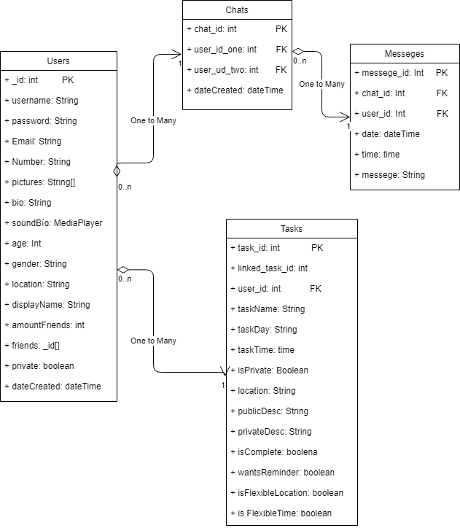

**Test Plan**

**Login Tests**

1. Test Register functionality for new users
   1. Test against SQL
2. Test Password reset for users
3. Test Successful Login functionality for existing users
4. Test Failed Login functionality for existing users

**Search Tests**

1. Test Search for another user by username
2. Test Search for another user by Display name
3. Test search for Tasks by name
4. Test search for Tasks by description
5. Test search for Tasks by Location
6. Test loading of other user profiles
7. Test loading of Tasks

**Message Tests**

1. Test sending another user a message
   1. Send Message
   2. Log-out
2. Test Receiving message from another user
   1. Log in as other user
   2. Check for message
3. Test Notification of new message
   1. Run two devices

**Profile Tests**

1. Test creation and edit of Bio
2. Test creation and playback of Sound Bio
3. Test addition, removal, and view of pictures
4. Test edit of DisplayName
5. Test View of to do List
6. Test Message button
7. Test Favorite / Friend button
8. Test Edit of Private Account info
9. Test Edit of Password
10. Test Deletion of Account

**To do List Tests**

1. Test addition of new task
   1. Test creation of require parameters
   2. Test optional functions
   3. Test private vs public descriptions
2. Test Removal of an existing task
3. Test edits of existing task
4. Test edit of existing linked tasks

**Deliverables Timeline**

|  |  |
| --- | --- |
| Week | Task(s) |
| 1 (AUG 31th – SEPT 4th) | Setup development environment and database Host. |
| 2 (SEPT 7th – SEPT 11th) | Create Database tables and relations.  Set up Base layouts for pages |
| 3 (SEPT 14th – SEPT 18th) | Create Login Functionality  Create Register Functionality |
| 4 (SEPT 21th – SEPT 25th) | Fill database with test data.  Create Profile functionality |
| 5 (SEPT 28th – OCT 2nd) | Create Search functionality for Users. |
| 6 (OCT 5th – OCT 9th) | Create Search functionality for Tasks |
| 7 (OCT 12th – OCT 16th) | Create base of To do List functionality |
| 8 (OCT 19th – OCT 23rd) | Create to-do list task addition functionality |
| 9 (OCT 26th – OCT 30th) | Create deletion and edit functionality of To do lists |
| 10 (NOV 2nd – NOV 6th) | Integrate To do/Profile Functionality |
| 11 (NOV 9th – NOV 13th) | Create Message Functionality |
| 12 (NOV 16th – NOV 20th) | Final Test Login/ Register Functionality  Final Test Search Functionality |
| 13 (NOV 23rd – DEC 27th) | Test Profile  Test To do List Functionality  Test Message Functionality |

**Timeline suitable to change if time allows for an earlier start\***

**Deliverables**

**Android Application –** Final Android Application for view and review

**Database Access –** Access to the Database the application uses for review of tables and schema

**Presentation Materials –** All final presentation files and documents for reference

**Development Notes –** All development notes to view progress reports and timing

**Current Finished Timeline**

|  |  |  |  |  |  |
| --- | --- | --- | --- | --- | --- |
| **Milestone** | **Estimated Duration** | **Start** | **Finish** | **Complete?** | **Actual Time Spent** |
| Setup development environment and database Host. | 5 | 08/31 | 09/04 | Y | 4 hours |
| Create Database tables and relations.  Set up Base layouts for pages | 4 | 09/07 | 09/11 | Y | 5 hours |
| Create Login Functionality  Create Register Functionality | 4 | 09/14 | 09/18 | Y | 12 hours |
| Fill database with test data.  Create Profile functionality | 4 | 09/21 | 09/25 | Y | 18 hours |
| Create Search functionality for Users. | 4 | 09/28 | 10/02 | Y | 5 hours |
| Create Search functionality for Tasks | 4 | 10/05 | 10/09 | Y | 3 hours |
| Create base of To do List functionality | 4 | 10/12 | 10/16 | Y | 12 hours |
| Create to-do list task addition functionality | 4 | 10/19 | 10/23 | Y | 4 hours |
| Create deletion and edit functionality of To do lists | 4 | 10/26 | 10/30 | Y | 3 hours |
| Integrate To do/Profile Functionality | 4 | 11/02 | 11/06 | Y | 2 hours |
| Create Message Functionality | 4 | 11/09 | 11/13 | Y | 7 hours |
| Final Test Login/ Register Functionality  Final Test Search Functionality | 4 | 11/16 | 11/20 | Y | 0 hours |
| Test Profile  Test To do List Functionality  Test Message Functionality | 4 | 11/23 | 11/27 | Y | 0 hours |
| Create Final Presentation for the capstone | 4 | 11/30 | 12/04 | Y | 0 hours |

*Testing was done during the development of other parts to cut down on testing time**